Technical Datasheet 4G Gateway with 4DI, 4DO, & 4AI

Product Overview: -
The 4G Gateway is an advanced networking device designed to provide seamless connectivity and data management capabilities for various applications. With support for 4G LTE connectivity, cloud connectivity via MQTT protocol, and robust storage options, it offers a comprehensive solution for remote monitoring and control systems. Equipped with an integrated I/O interface featuring 4 Digital Inputs (DI), 4 Digital Outputs (DO), and 4 Analog Inputs (AI), alongside a Modbus RS485 port and micro SIM compatibility, it caters to a wide range of industrial and IoT applications. The intuitive web-based UI interface allows for easy configuration and management, making it an ideal choice for both professionals and enthusiasts.

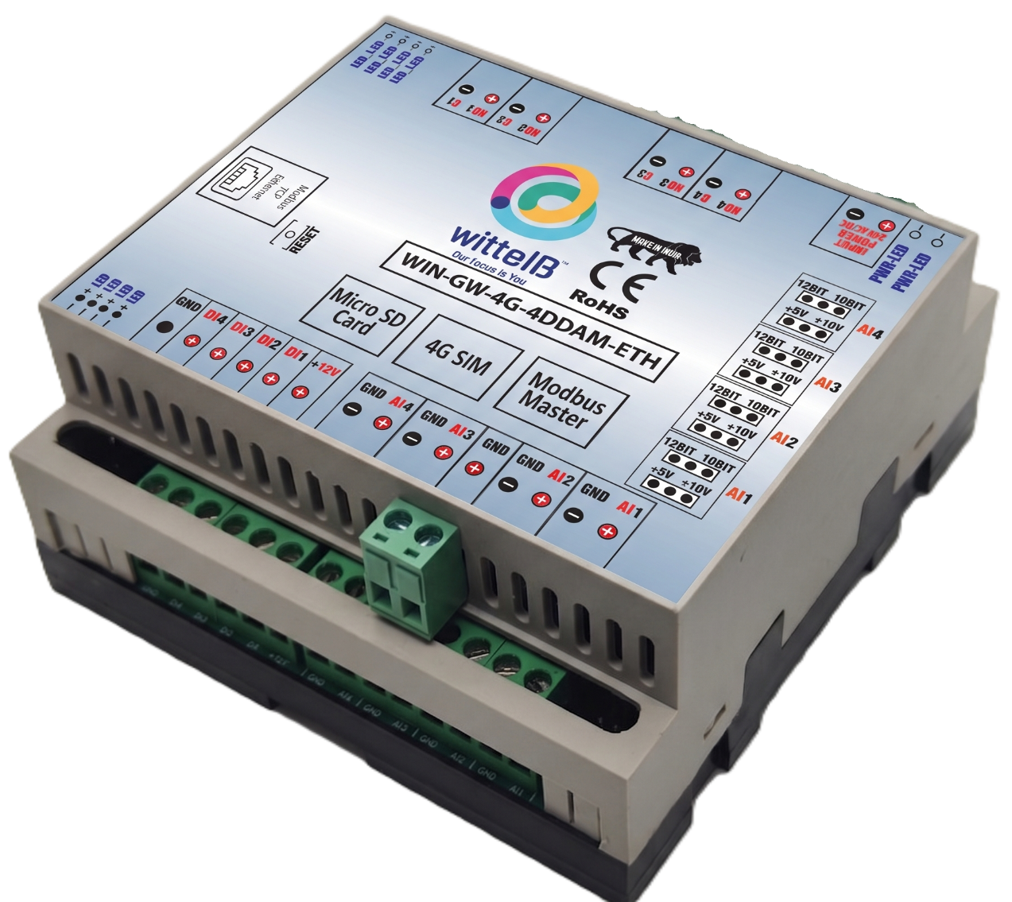

Specifications

General:-
- 4G LTE Connectivity: Utilizes 4G LTE technology for reliable and high-speed internet access. If 4G is not available, the system automatically switches to Wi-Fi. If both 4G and Wi-Fi are unavailable, the data is securely stored in the SD card for later upload.
- Cloud Connectivity (MQTT): Seamlessly connects to cloud platforms using the MQTT protocol for efficient data transmission and management.
- Event Storage: Offers on board event storage, capable of storing up to 50,000 events or more. Includes an external memory card slot for easy data retrieval in the event of 4G network issues.
- Modbus RS485 Port: Features 1 port of Modbus RS485 for integration with industrial control systems and sensors.
- GPS Location Data: Provides GPS location data for monitoring of remote equipment.
- Micro Sim Compatibility: Supports micro-Sim card for flexible and convenient connectivity option.
- Web-based UI Interface: Intuitive web-based user interface for easy configuration, monitoring, and management.
- Dimensions: 110 mm L x 110 mm B x 50 mm H.
- Power: Input Power – 15-40 VDC, Typical – 12V DC @ 150mA.
- Operating Temperature: 0 – 60C (32 ~ 140F).
- Storage Temperature: 20 - 70C (-4 ~ 158F).
- Storage Humidity: 5 ~ 95 % RH, non – Condensing.

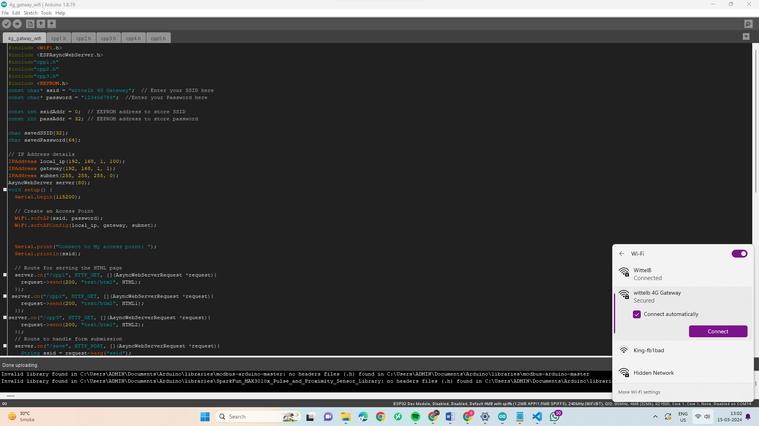
Configuration Settings: -
- Power up the module by connecting a 12-24 V DC supply.
- Insert the SIM card into the designated slot.
- Place the Micro SD card into its designated slot.
- Connect MODBUS RTU Multiple Slave devices (up to 31) to the A & B Terminal
Of Module.
- Access the module's configuration hotspot
(ID: Wittelb-4G-GATEWAY, PASS: 123456789).
- Default IP Address of Module is “192.168.1.100/cpp1”.
- Upon entering the provided IP address, a configuration webpage
Pages will be accessible.

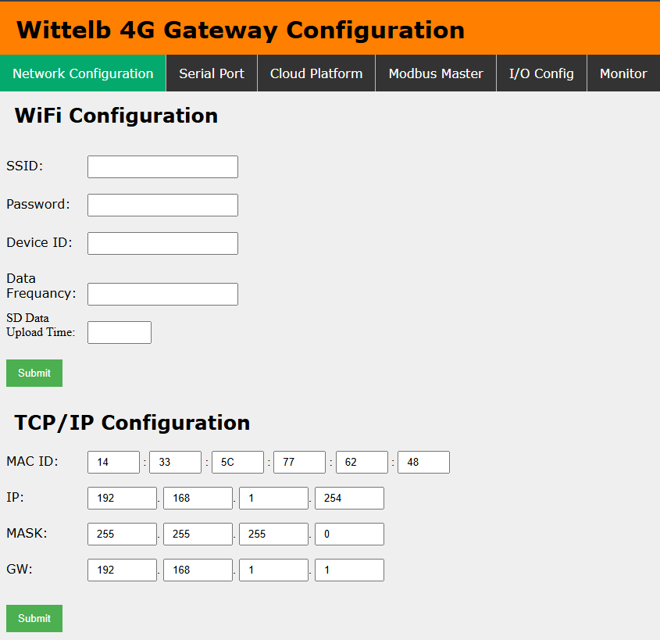
Page1:- TCP/IP Configuration:-
- Enter MAC ID of the Ethernet interface (6 hex bytes, e.g. 14:33:5C:77:62:48).
- Enter IP address for the Ethernet port (default: 192.168.1.254).
- Enter Subnet Mask (default: 255.255.255.0).
- Enter Gateway address (default: 192.168.1.1).
- Click Submit to save settings; the module applies to the new Ethernet configuration immediately.
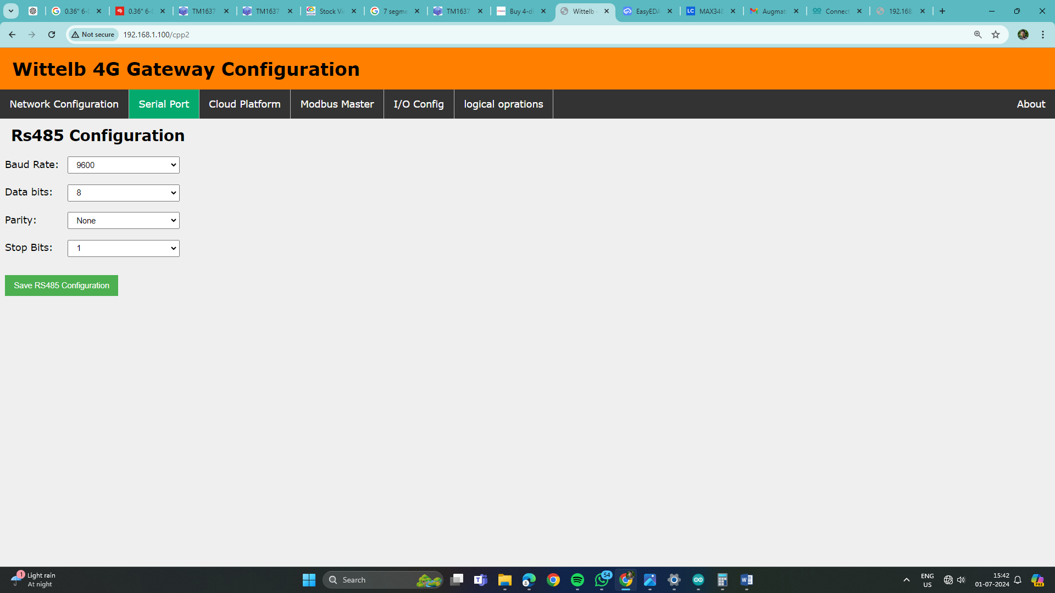
Page2:- On second page you can set device Baud Rate (9600 / 19200 / 38400 / 57600 / 115200), Data Bits (5 / 6 / 7 / 8), Parity (None / Odd / Even), and Stop Bits (1 / 2) for RS485 Communication
Page3:-
      - Navigate to page 3 on the cloud platform.
      - Input the Host IP or Domain.
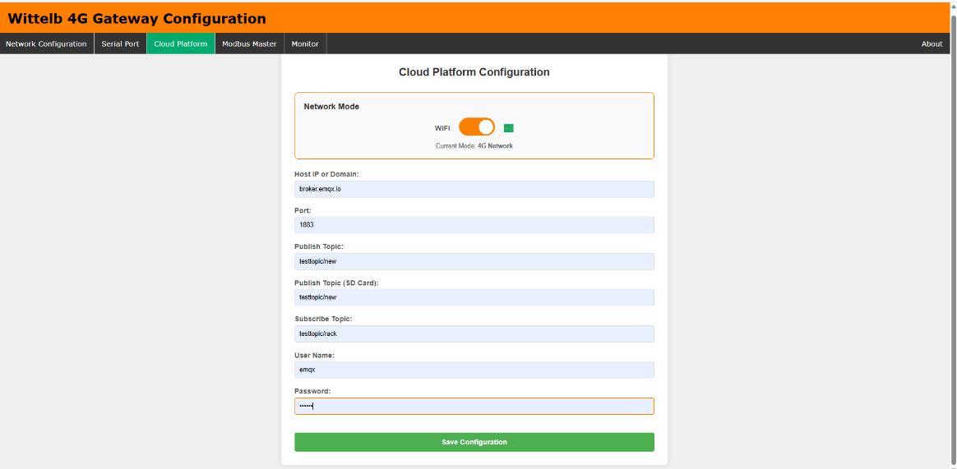
      - Enter the port Number.
      - Enter the topics for publishing and receiving messages.
      - Provide a username and password if required.
      - Allow a few seconds for the module to restart and establish a connection to MQTT.

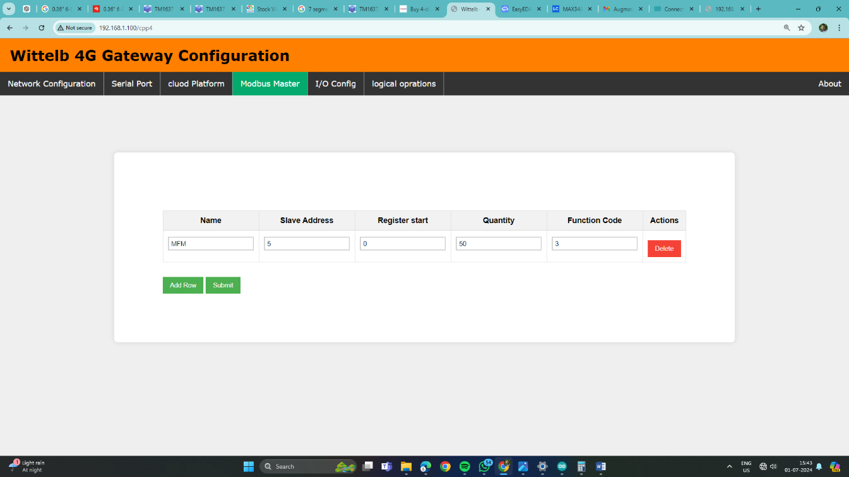
Page4:-
- Go to page 4 on the Modbus Master interface.
- Input the name and slave address for the designated slave.
- Specify the register address from which you want to read slave data.
- Indicate the register end address for the slave.
- Enter the function code corresponding to the desired slave.

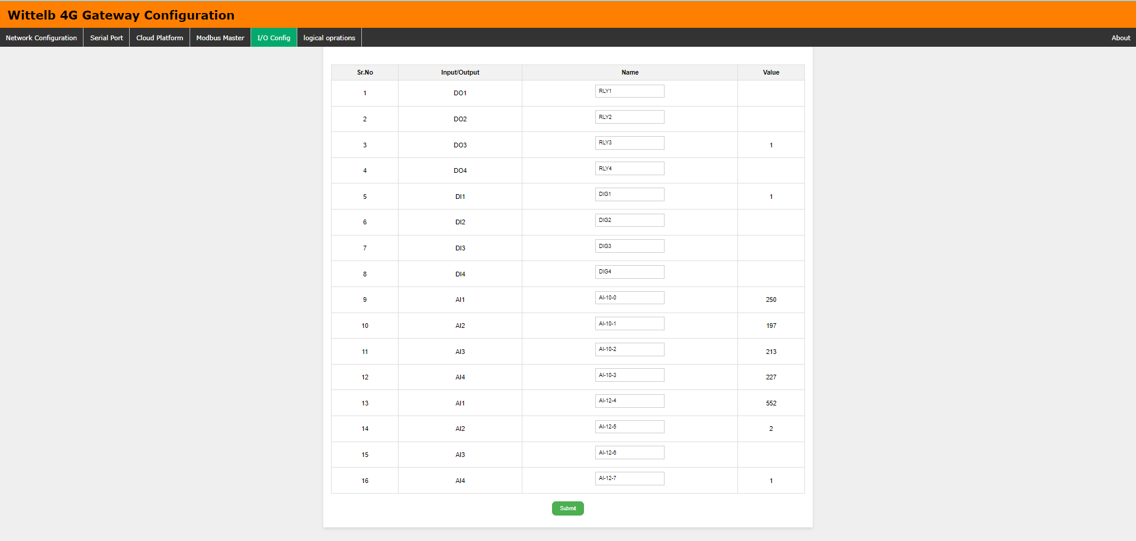
Page5:-
- Go to page 5 on the I/O Config interface.
- You can view real-time values of both analog and digital inputs on the baseboard.
- Additionally, you have the option to assign specific names to each input/output
(I/O) as needed.
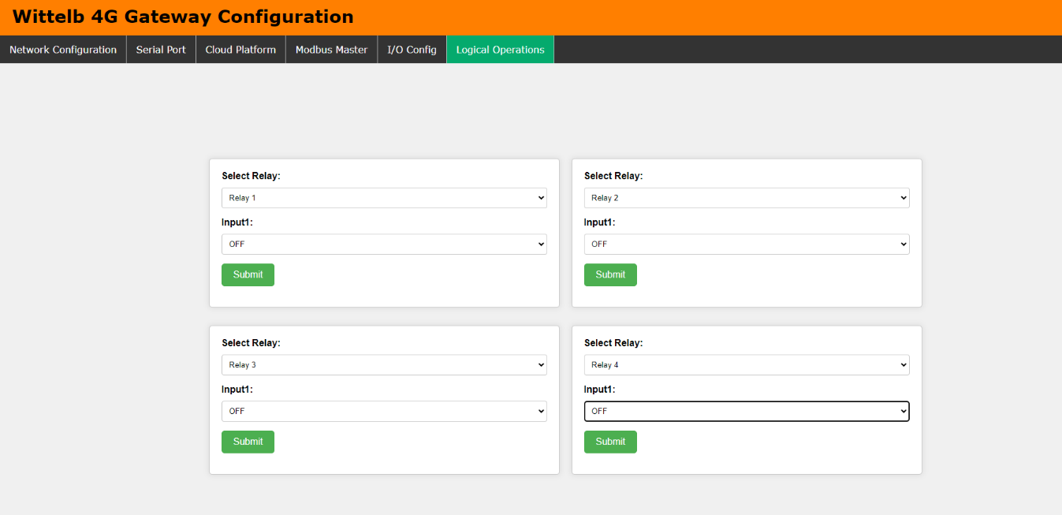
Page6:-

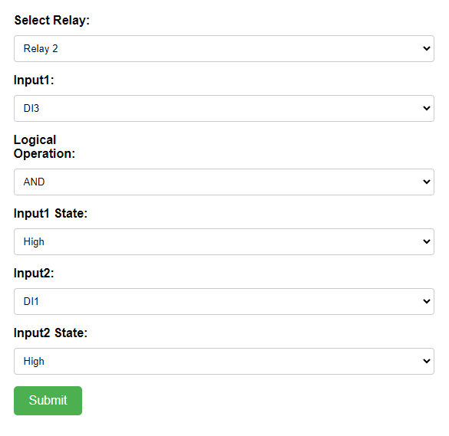
- Navigate to page 6 on the Logical Operations interface.
- Here, you can configure logical AND and OR operations for each of the 4 relays.
- You have the flexibility to assign any two digital inputs to a relay and choose the desired logical operation.
- Additionally, you can assign an analog input to a relay and define minimum and maximum threshold values for relay operation.
- If you prefer not to use any logical operation, simply select the "OFF" option for
input one.

Input & Output module Configuration Settings: -

- The Gateway has 4 Digital Outputs (DO) with Relay of 10 Amps 230V,
- 4 Analog Inputs (AI) to connect with 4-20ma or 0-10 v sensors,
- 4 Digital Inputs (DI) will help monitor the status with logic voltage input between 4-40V DC. Additionally, we have also provided 12 V voltage ref and GND pins for DI detection logic.
- Digital outputs are normally open.
- Data of Digital Inputs (DI) and Analog Inputs (AI) would be directly collected by the Processor and transmitted over 4G to the Cloud based on the Poling frequency.
- Configure each Analog Input (AI) to operate with either 5V or 10V and choose between 10-bit and 12-bit resolution by adjusting the jumper settings.
- You can trigger DO from cloud by sending Following Message

Relay No | ON | OFF
DO1 | "DO1":1 | "DO1":1
DO2 | "DO2":1 | "DO1":1
DO3 | "DO3":1 | "DO1":1
DO4 | "DO4":1 | "DO1":1

4G Gateway connection Diagram:

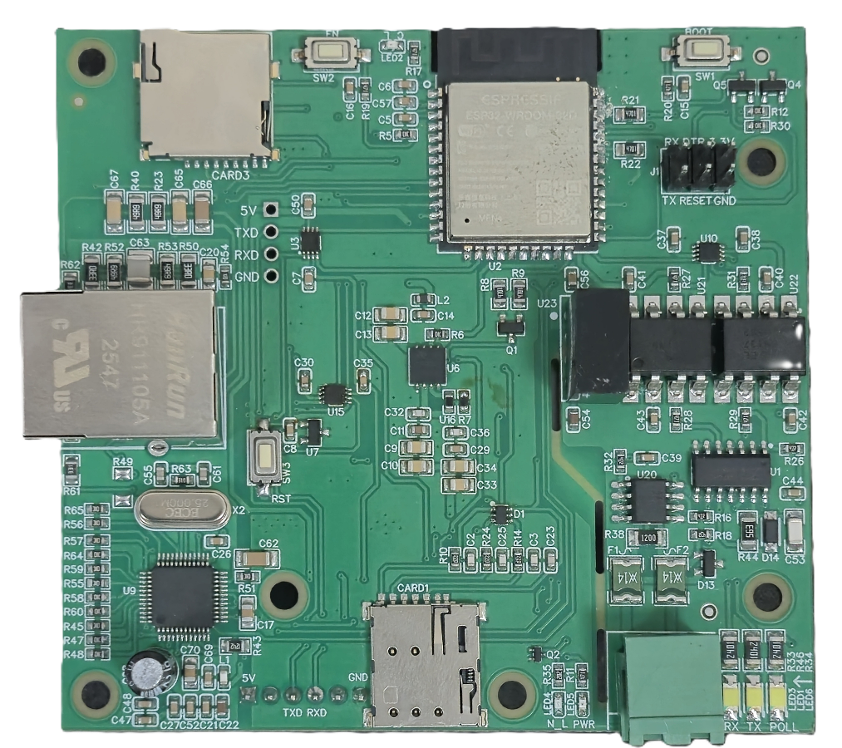
SD Card Slot

Sim Card Slot

Modbus [A-B]

RS485 & Polling
Led

ETHERNET PORT

Additional Features: -
Communication ports are isolated
Input power reverse polarity safety
ESD Safety IEC 61000-4-2, ± 30KV contact, ± 30KV air
EFT IEC 61000-4-4, 50A (5/50ms)
400V isolation.

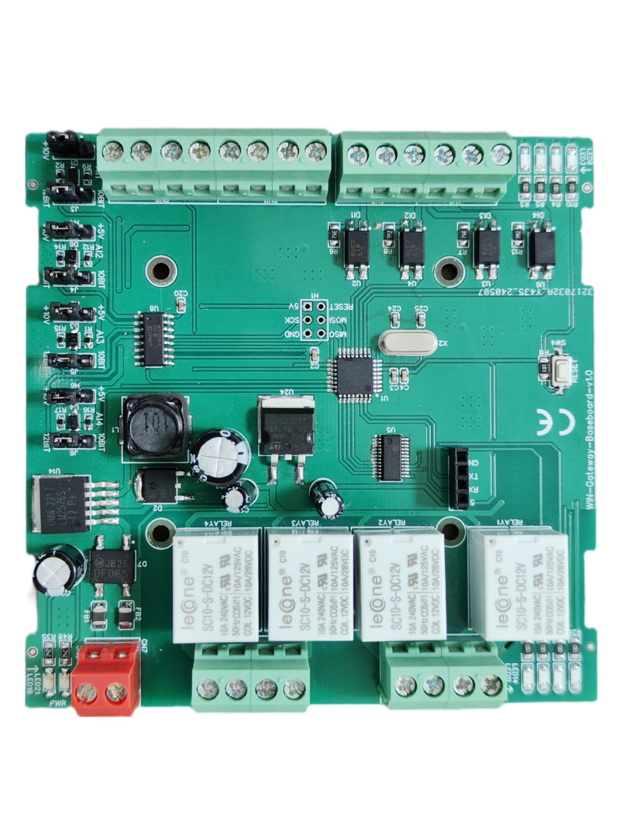
Contact us: -
PWR 24V AC/DC

DO1 | DO2

DO3 | DO4

AI1 | AI2

AI3 | AI4

+12V|DI1|DI2|DI3|DI4|GND

Analog input 10/12-bit selection jumper

r
Led indication of I/O
Augmatic Technologies Pvt. Ltd.,
Plot no 6, Shah Industrial Estate II,
Kotambi,
Vadodara – 391510.
Email – Sales@wittelb.com

